HEART DISEASE PREDICTION MODEL

Project Id: AIML-13

Name : Vanshika Maheshwari (Team Leader)
Class Roll Number:78
University Roll Number : 2028916
Section and Group: G,G2

Name : Priyanshi Tamta
Class Roll Number:55
University Roll Number : 2028809
Section and Group: G,G2

TABLE OF CONTENTS
- Problem Description 3
  - Dataset Description 3
  - Flow diagram 5
- Modules for Project Implementation…………………..…………………………6
  - Modules Used 6
  - Platform Used 9
- Machine Learning model/ Searching Technique used 10
- Evaluation metrics used 12
- Results and Visualizations 14
- Conclusion and Future Scope 16
- References 17

- Problem Description
Design and develop an end-to-end machine learning classification system to predict
heart disease risk using patient clinical health data. The project should include selecting
a suitable heart disease dataset and performing preprocessing steps such as cleaning
missing values, normalization/standardization of medical features, and transformation
of categorical variables (e.g., encoding). Relevant clinical features should be identified
using feature selection methods to enhance interpretability and prediction performance.
The system must include model selection and training using Logistic Regression, KNN,
and SVM classifiers. The trained models must be evaluated using standard performance
metrics such as accuracy, precision, recall, F1-score, confusion matrix, and ROC curve.
The project should demonstrate a complete machine learning pipeline starting from raw
patient records and ending with evaluated predictive models for heart disease
classification.
Expected Output
0: No Heart Disease
1: Heart Disease Present

  - Dataset Description

The dataset used for this project is a Heart Disease Prediction dataset containing 918 records and 16 attributes, collected to analyze patient health parameters and predict the presence of heart disease. The dataset includes demographic, clinical, and exercise-related features that influence cardiovascular health.
The target variable in the dataset is HeartDisease, a binary classification attribute where 1 indicates presence of heart disease and 0 indicates absence of heart disease.
The dataset consists of both numerical and categorical attributes. Numerical attributes include Age, Resting Blood Pressure (RestingBP), Cholesterol, Fasting Blood Sugar (FastingBS), Maximum Heart Rate (MaxHR), and Oldpeak (ST depression induced by exercise). Categorical attributes such as Sex, Chest Pain Type, Resting ECG results, Exercise-Induced Angina, and ST Slope were converted into numerical form using one-hot encoding during preprocessing.
The major attributes used in the dataset are:
- Age: Age of the patient
- Sex: Gender of the patient
- ChestPainType: Type of chest pain experienced
- RestingBP: Resting blood pressure level
- Cholesterol: Serum cholesterol measurement
- FastingBS: Fasting blood sugar indicator
- RestingECG: Resting electrocardiogram results
- MaxHR: Maximum heart rate achieved
- ExerciseAngina: Exercise-induced angina presence
- Oldpeak: ST depression induced by exercise
- ST_Slope: Slope of peak exercise ST segment
- HeartDisease: Target variable for prediction

1.2 Flow Diagram

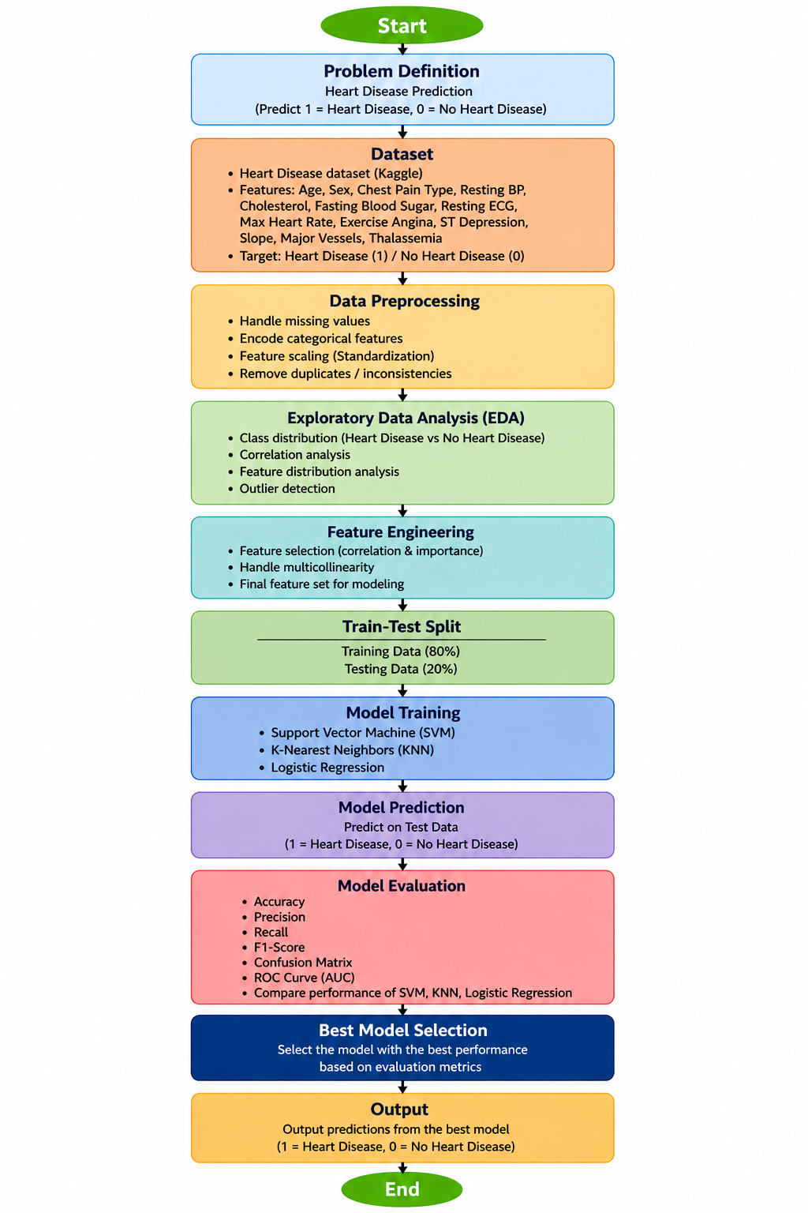

2. Modules for Project Implementation

2.1 Modules Used(mention all the inbuilt/ custom modules used and the purpose)

- Pandas – Pandas module has been used for data manipulation and analysis.
Functions used:
- pd.read_csv- to read data from csv file in a pandas dataframe.
- df.head() – To display the first few records of the dataset.
- df.drop() – To separate input features and target variable.
- df.columns – To retrieve feature names after feature selection.

- NumPy – NumPy module has been used for numerical computations and array-based
operations during preprocessing and model implementation.

Functions used:
- np.array() – To handle data in array format for machine learning models.
- np.where() – For conditional numerical operations (used during preprocessing where required).

3. Pickle – Pickle module has been used to serialize and save the trained machine learning
model and preprocessing objects for later prediction.
Functions used:
- pickle.dump() – To save trained model, scaler, selector and feature list into .pkl files.

4.Scikit-learn (sklearn.model_selection) – Used for splitting data and hyperparameter tuning of the. machine learning model.
Functions used:
- train_test_split() – To split dataset into training and testing sets.
- GridSearchCV() – To perform hyperparameter tuning using cross-validation.
5.Scikit-learn (sklearn.preprocessing) – Used for data preprocessing and normalization before model training.
Functions used:
- StandardScaler() – To standardize feature values before model training.
- fit_transform() – To scale training data.
- transform() – To scale test data using trained scaler.
6. Scikit-learn (sklearn.feature_selection) – Used for selecting the most relevant features for model training.
Functions used:
- SelectKBest() – To select top important features.
- f_classif – ANOVA F-test used for feature scoring.
- SequentialFeatureSelector() – Imported for sequential feature selection.
- get_support() – To retrieve selected feature names.

7. Scikit-learn (sklearn.linear_model) – Used for implementing the Logistic Regression classification model.
Functions used:
- LogisticRegression() – To train the final prediction model.
- predict() – To generate class predictions.
- predict_proba() – To generate probability scores for ROC analysis.

8. Scikit-learn (sklearn.metrics) – Used for evaluating model performance.
Functions used:
- accuracy_score() – To calculate model accuracy.
- precision_score() – To measure prediction precision.
- recall_score() – To measure model recall.
- f1_score() – To calculate F1-score.
- roc_auc_score() – To compute ROC-AUC score.
- confusion_matrix() – To generate confusion matrix.
- roc_curve() – To plot ROC curve.
- auc() – To calculate area under ROC curve.

9. Seaborn – Seaborn has been used for data visualization and plotting heatmaps for model evaluation.
Functions used:
- sns.heatmap() – To visualize confusion matrix using heatmap.

10. Matplotlib – Matplotlib module has been used for graphical visualization of results and model performance.
Functions used:
- plt.figure() – To create figure canvas.
- plt.plot() – To plot ROC curve.
- plt.xlabel() – To label x-axis.
- plt.ylabel() – To label y-axis.
- plt.title() – To provide plot titles.
- plt.show() – To display visualizations.

2.2 Platform Used: (mention all the platforms with the reason of using it)
  - Visual Studio Code: For code writing, testing, and debugging.
VS Code is equipped with multiple extensions, debugger which enhance the development experience.

- Jupyter Notebook: For data preprocessing, exploratory data analysis, model training and visualization.
Jupyter provides an interactive environment to execute code cell-by-cell, making it useful for experimentation, testing machine learning models and visualizing results.

- GitHub: For version control and project repository management.
GitHub was used to store project files, manage code updates and collaborate efficiently during project development.

3. Machine Learning Model/ Searching Technique Used(Describe each ML model/ searching technique used)

1.Logistic Regression
Logistic Regression is a supervised machine learning classification algorithm used for predicting binary outcomes. In this project, it is used to classify whether a patient has heart disease (1) or does not have heart disease (0).
It works using the sigmoid function, which converts predictions into probabilities between 0 and 1.
Sigmoid Function:
$$P(y=1)=\frac{1}{1+e^{-(b_{0}+b_{1}x_{1}+b_{2}x_{2}+⋯+b_{n}x_{n})}}$$
Where:
- $P(y=1)$ = probability of heart disease
- $b_{0}$ = intercept
- $b_{1}...b_{n}$ = model coefficients
- $x_{1}...x_{n}$ = input features
Logistic Regression was selected as the final model because it provides good classification performance, is computationally efficient, and is easy to interpret.

2. Feature Selection using SelectKBest
Feature selection was performed using SelectKBest with ANOVA F-test (f_classif) to select the most relevant features contributing to heart disease prediction.
This technique evaluates all features statistically and selects the top k most significant features. In this project, 10 important features were selected to improve model performance and reduce irrelevant attributes.
Selected features included:
Age, RestingBP, MaxHR, Oldpeak, Sex_M, ChestPainType_ATA, ChestPainType_NAP, ExerciseAngina_Y, ST_Slope_Flat, and ST_Slope_Up.

3. Hyperparameter Tuning using GridSearchCV
GridSearchCV was used as the searching technique for hyperparameter optimization of Logistic Regression.
It systematically tests multiple combinations of parameters using 5-fold cross-validation and selects the best combination based on model performance.
Parameters tuned:
- Regularization parameter (C): 0.01, 0.1, 1, 10
- Solver: liblinear, lbfgs
Best parameters obtained:
- C = 0.01
- Solver = liblinear

4. Evaluation metrics used (Describe each evaluation metric used along with formulae)

1. Accuracy
Accuracy measures the proportion of correctly classified instances out of the total observations.
$$Accuracy=\frac{TP+TN}{TP+TN+FP+FN}$$
Where:
- TP = True Positives
- TN = True Negatives
- FP = False Positives
- FN = False Negatives
Higher accuracy indicates better overall model performance.

2. Precision
Precision measures how many predicted positive cases were actually positive.
$$Precision=\frac{TP}{TP+FP}$$
High precision means fewer false positive predictions.

3. Recall (Sensitivity)
Recall measures how many actual positive cases were correctly identified.
$$Recall=\frac{TP}{TP+FN}$$
Higher recall indicates better detection of heart disease cases.

4. F1-Score
F1-Score is the harmonic mean of Precision and Recall and provides a balance between both metrics.
$$F1=2⋅\frac{Precision⋅Recall}{Precision+Recall}$$
It is useful when both false positives and false negatives are important.

5. ROC-AUC Score
ROC (Receiver Operating Characteristic) curve evaluates classification performance at different thresholds, while AUC (Area Under Curve) summarizes the model’s ability to distinguish between classes.
- TPR (True Positive Rate):
$$TPR=\frac{TP}{TP+FN}$$
- FPR (False Positive Rate):
$$FPR=\frac{FP}{FP+TN}$$
A higher AUC value indicates better classification performance.

6. Confusion Matrix
A confusion matrix was used to visualize model predictions and compare actual versus predicted classes.
It contains:
- True Positives (TP)
- True Negatives (TN)
- False Positives (FP)
- False Negatives (FN)
It helps in understanding classification errors made by the model.

5. Results and Visualizations

Accuracy: 0.8152173913043478
Precision: 0.8842105263157894
Recall: 0.7850467289719626
F1 Score: 0.8316831683168316
ROC AUC: 0.9086054132783105

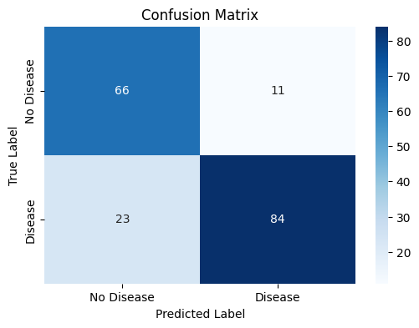

Confusion matrix showing the performance of the Logistic Regression model in classifying heart disease and non-heart disease cases.

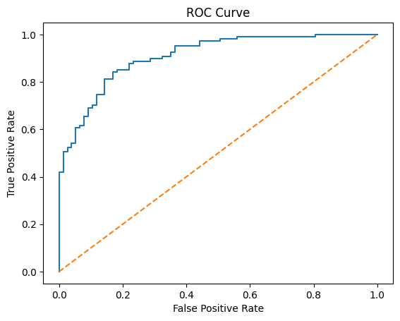

ROC curve showing the classification performance of the Logistic Regression model and its ability to distinguish between heart disease and non-heart disease cases

6. Conclusion and Future Scope:

Conclusion
This project successfully developed a Heart Disease Prediction System using Machine Learning techniques to predict the likelihood of heart disease based on patient health parameters. Data preprocessing, feature selection using SelectKBest, and hyperparameter tuning using GridSearchCV improved the performance of the model. Among the techniques applied, Logistic Regression produced effective classification results with good accuracy and reliable predictive performance. Evaluation through confusion matrix, ROC curve, accuracy, precision, recall and F1-score demonstrated that the model can effectively assist in early heart disease prediction and support medical decision-making.

Future Scope
The project can be further improved by:
- Using larger and real-time medical datasets to improve prediction accuracy.
- Testing advanced machine learning algorithms such as Random Forest, XGBoost and Deep Learning models.
- Developing a web or mobile-based interface for practical clinical use.
- Integrating additional health parameters and patient history for more robust prediction.
- Extending the system into a real-time decision support tool for healthcare applications.

7. References:
Books:
- Let Us Python – Yashavant Kanetkar

Online Resources:
  - GeeksforGeeks – https://www.geeksforgeeks.org/
  - TutorialsPoint – https://www.tutorialspoint.com/cprogramming/index.htm
  - Stack Overflow – https://stackoverflow.com

